

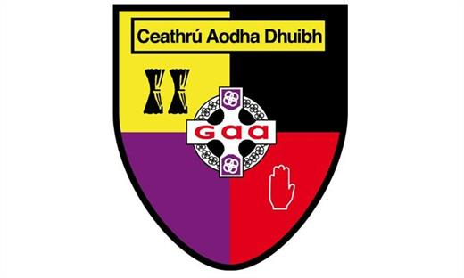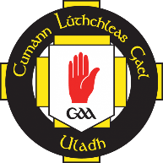

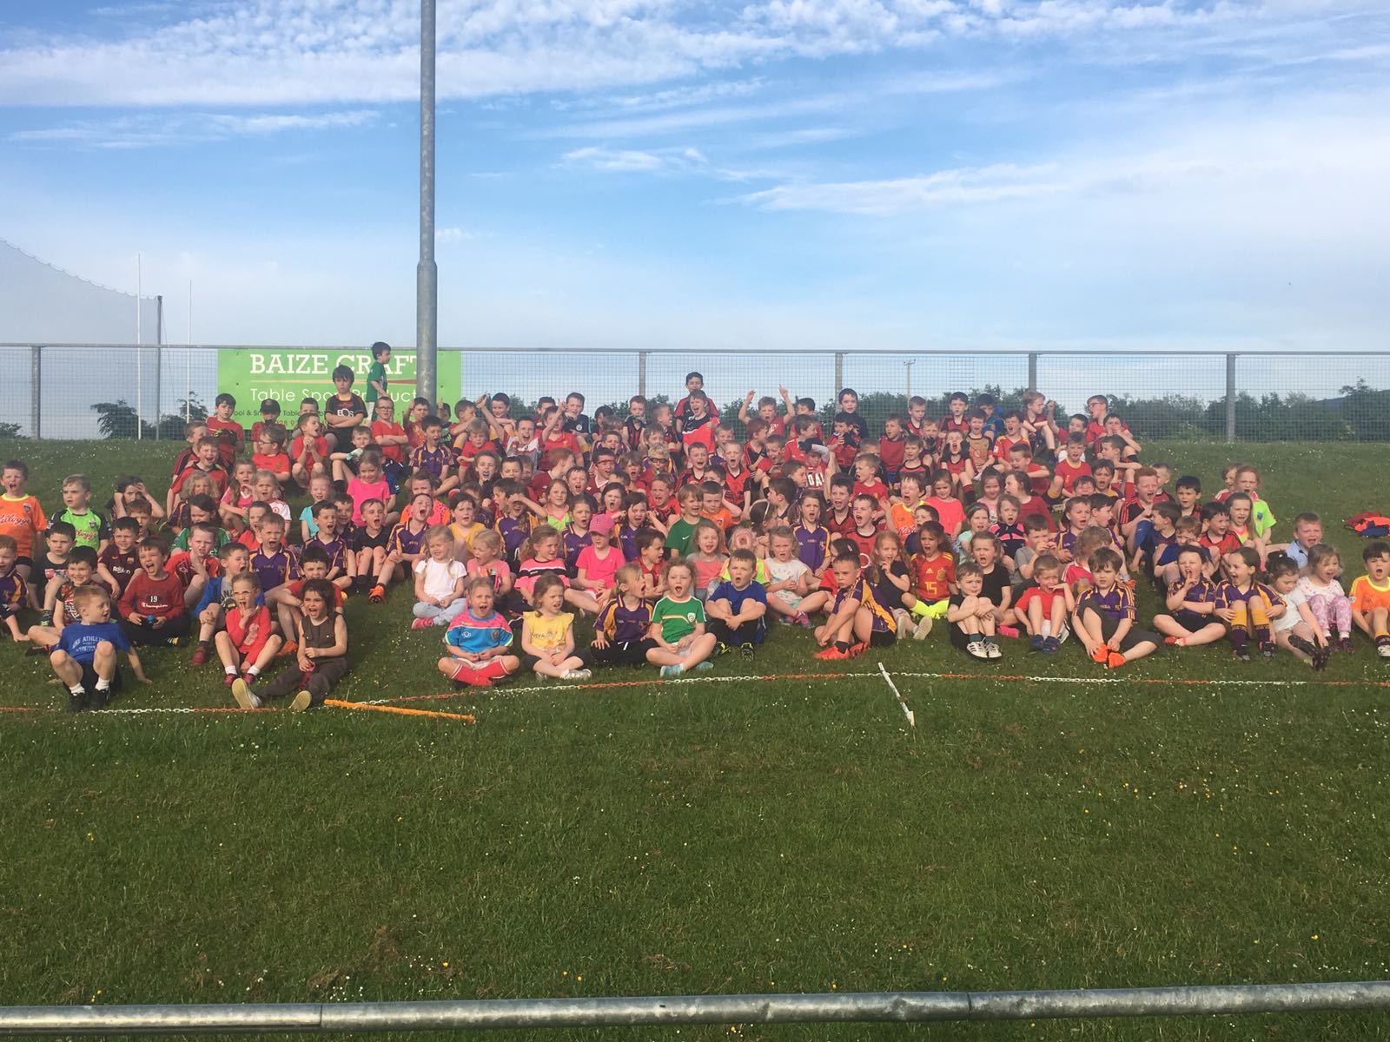

Carryduff GAC

2023 Nursery Academy

Parent/Guardian Information

2023 Nursery Academy Sponsor:

**Chairperson’s Foreword**

We extend a huge welcome to the parents/guardians and children to Carryduff GAC. For many of you, participation in the Nursery Academy will not only be the first involvement with our club, but also the GAA. If this is the case, we want to extend a warm welcome to you and your family and hope that your experiences, for the coming year and beyond will, like ours, be immensely positive. For returning participants– welcome back to C.L.G Cheathrú Aodha Dhuibh!

The Nursery Academy is open to Nursery School and Primary 1, regardless of religion, race or ability. Many of our current senior male and female players were first exposed to Gaelic games through participation with our Academy. They have gone on to represent our Club at various levels in Football, Hurling and Camogie; forging lifelong friendships with teammates and coaches, whilst becoming key members of our local community. Some have also gone on to represent their county. There is no reason why your child can not also achieve similar feats.

The primary aim of the Nursery Academy is FUN. However, it will also expose your child to the ‘Fundamental Movement Skills’ known as the ABCs: **A**gility; **B**alance; and **C**o-ordination. The training sessions that your child will undertake, have been designed by experienced coaches, will endeavour to teach your child the basic motor skills of all Gaelic games through fun.

Due to the large numbers of children involved, we, as a volunteer organisation, need you to assist us. Please be aware that all members of our Club are volunteers and, like you, have children, demanding jobs and family commitments. Our Club “works” because of the commitment of all our volunteers. We hope that you will join us and assist in the Nursery Academy. Without your participation we cannot run the Academy. Be part of the journey, club community and wider GAA family.

We hope that you do decide to get involved in whatever way that you can and that you also consider becoming a member of Carryduff GAC to help grow our club so that it can realise its full potential.

We wish you and your child all the best for the year ahead.

*Brendan Sloan - Carryduff GAC Chairperson*

**Table of Contents**

**Introduction to Carryduff GAC2**

Welcome 2

Location and Facilities 2

**Mission, Vision & Values of Carryduff GAC** 3

Mission 3

Vision 3

Our Six Core Values 4

**Nursery Academy Information** 5

Who is it for? 5

When Does it Take Place? 5

Aims/Ethos 5

What Your Child Will Learn 6

Nursery Academy Structure and Working Group Contact Details 6

Helping Out 7

Membership 8

Communication 9

Cancellations 9

Medical Conditions/Allergies 9

First Aid 9

Parental/Guardian Attendance/Involvement 10

Photography 10

Additional Hurling/Camogie Training 11

Additional Football Training 11

Clothing and Equipment11

Mentor/Coaching Courses Available 12

Child Protection Course/Access NI 12

**Appendix A – Joining ‘Heja’ Instructions13**

**Appendix B – Access NI Registration Guide17**

**Introduction to Carryduff GAC**

**Welcome**

Welcome to Carryduff GAC. We have 38 teams across all age groups playing within 6 Codes: Ladies Football; Male Football, Hurling, Camogie, Handball and Rounders. We are based in Co. Down and have >1400 members, some of whom have been with us from when our club was established in 1971.

**Location and Facilities**

**Address:** Carryduff GAC

Knockbracken Drive

Belfast

BT8 8EX

Some of the main facilities within our Club grounds are as follows:

Pitch 1

Pitch 2

The Hub

Club House

4G Pitch

Health and Wellbeing Centre

Club Entrance (Pedestrian Only)

**Mission, Vision & Values of Carryduff GAC**

Like all Clubs in the GAA, we are a voluntary organisation. Our Coaches, players and all volunteers give up their time willingly to help develop Gaelic Games in Carryduff.

The GAA’s values are the heart and soul of Carryduff GAC. In common with every Club around the world, these values are what bind us, what makes us members of a unique association and helps to attract more and more players, members, volunteers and supporters.

**Mission**

*“Carryduff GAC is a community based volunteer organisation promoting Gaelic games, culture and lifelong participation.”*

We develop and promote Gaelic games at the core of Irish identity and culture.

We are dedicated to ensuring that our family of games, and the values we live, enrich the lives of our members, families and the communities we serve.

We are committed to active lifelong participation for all and to providing the best facilities.

We reach out to and include all members of our society.

We promote individual development and well-being and strive to enable all our members achieve their full potential in their chosen roles.

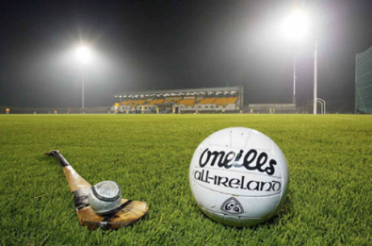

**Vision**

*Our vision is that everybody has the opportunity to be welcomed to take part in our games and culture, to participate fully, to grow and develop and to be inspired to keep a lifelong engagement with our Association.*

**Our Six Core Values**

1. **Community Identity**

* Community is at the heart of our Association. Everything we do helps to enrich the communities we serve
* We foster a clear sense of identity and place

1. **Amateur Status** 
   * We are a volunteer led organisation
   * All our members play and engage in our games as amateurs
   * We provide a games programme at all levels to meet the needs of all our players
2. **Inclusiveness** 
   * We welcome everybody to be part of our Association
   * We are anti-sectarian
   * We are anti-racist
3. **Respect** 
   * We respect each other on and off the playing fields
   * We operate with integrity at all levels
   * We listen and respect the views of all

1. **Player Welfare**

* We provide the best playing experience for all our players.
* We structure our games to allow players of all abilities reach their potential

1. **Teamwork**

* Effective teamwork on and off the 􏰀field is the cornerstone of our Association
* Ní neart go cur le chéile

(There is no strength without working together)

**Nursery Academy Information**

**Who is it for?**

The 2023 Nursery Academy is for children born between 02/07/2017 and 01/07/2019. The Academy will be split into two distinct groups based on when your child was born. For 2023, the name of each group and associated ‘born on date’ bands are as follows:

|  |  |
| --- | --- |
| **Group** | **Date of Birth Band** |
| Nursery School | 02/07/2018 - 01/07/2019 |
| Primary 1 | 02/07/2017 – 01/07/2018 |

If your child was born outside of these dates and you are keen to give them an introduction to Gaelic Games please contact the Nursery Academy Co-Ordinators for further information.

**When does it take Place?**

The Nursery Academy takes place on Saturday mornings commencing on 15th April and finishing at the end of September/start of October. Please note that sessions typically do not run over Easter (if applicable), the July holiday period (for one week). Further updates on the Nursery Academy programme will be communicated to Parents/Guardians throughout the year.

**Aims/Ethos**

* Provide a safe, fun and enjoyable environment for the physical and mental development of the children involved;
* Provide a safe, fun and enjoyable environment for the coaches and helpers involved;
* Provide a well organised, structured programme giving children (and parents) an introduction to all Gaelic games and provide quality coaching in these sports;
* Maximise the number of participants returning week on week and year on year; and
* Promote GAA sports to all involved.

**What Your Child Will Learn**

The sessions for each age group have been developed by experienced coaches within our club with an emphasis on fun. Each week, the sessions will be tweaked slightly to maintain interest of the children and coaches helping out.

As a GAA Academy, the children will get to take part in learning the skills of all GAA codes along with developing their overall physical development by:

* Providing the opportunity to be coached in boys and girls football, hurling and camogie;
* Participating in exercises that will develop their ABC’s (Agility, Balance and Co-ordination) as well as basic running, jumping, catching, kicking and throwing etc. (The children need to be able to participate in games independently.)

**Nursery Academy Structure and Working Group Contact Details**

In a lot of previous years, the Nursery Academy was typically run by 1-2 volunteers, with the assistance of parents/guardians as coaches during sessions. However, the growing popularity of our Nursery Academy, (which frequently sees >100 children attend each morning) coupled with the extensive administration requirements to run the Academy safely, led to a redesign of how we do things. Our philosophy is to grow the Nursery Academy sustainably by ensuring that the workload is borne by the many, rather than the few.

In 2023, we have introduced a ‘Working Group’ for the Academy. This is comprised of a small group of parents who have the overall responsibility of co-ordinating, administering and coaching for the Academy. The parents (in no particular order) involved are:

* Chris Scott - Coach
* Claire Morris – Admin
* Conor Mullan - Coach
* Gareth Moore - Coach
* Joanne Friel - Coach
* Jonathan Strain - Coach
* Mark McGovern - Coach
* Myles McCann - Coach
* Paula Lamont - Admin
* Ruairi Boyle - Coach

They can be contacted on Heja if required.

The Working Group is responsible for sourcing volunteers to help as coaches for each age group, assist with the pitch/stations setup, act as timekeepers and provide First Aid etc. We would be delighted if you could volunteer and help contribute.

The image below illustrates the location of the sessions, specific to each Group:

**Nursery School**

**P1**

**Sign In**

Please ensure that you sign your child in to each and every session.

**Helping Out**

Volunteers are the lifeblood of Carryduff GAC and the GAA. Our Coaches, players and all members give up their time willingly to help develop Gaelic games in Carryduff. Your help as a Parent/Guardian is essential for the successful running of the Nursery Academy.

The Nursery Academy is run solely by the Parents/Guardians of the children across the 2 age groups. We not only need assistance with coaching but also a number of other roles such as: pitch set up; managing training equipment; lost children; first aid; role taking; time keeping and many more. Please make yourself known to one of the Working Group members and ask if you can assist in any way.

As reflects society itself, the GAA has now an increased bureaucratic burden and in essence this means the following are required to coach within the GAA environment.

1. A member of Carryduff GAC

2. Safeguarding Course

3. Access NI Vetting Clearance

4. Introduction to Coaching Gaelic Games

We know this places time and extra financial burden on parents but we are bound by the GAA regulations and in fairness the spirit of these is to ensure a safe and enjoyable environment for our kids.

As a club we will support you in any way we can to fulfil the criteria. Please don’t be put off as coaching is a massively rewarding endeavour. You would be welcomed with open arms into Carryduff GAC.

If anyone would be interested in helping with coaching / mentoring / chaperoning / first aid or has any questions regarding any of the above, please do not hesitate to get in contact with our coaching officer Orla Napier 07789758452 or [**orlanapier@yahoo.co.uk**](mailto:orlanapier@yahoo.co.uk)

If we are short of volunteers for a session, we will have to limit the number of participants involved or not be able to run the session and this is something we do not want to see happening.

**Please be aware that absolutely no experience is required to help out!** You do not need to have had a GAA background or have played Gaelic games before. The more Parents/Guardians that help out the more enjoyable the sessions are for everyone involved. Please remember that the ethos of the Nursery Academy is FUN!

**Membership**

Due to insurance requirements, the club must impose a ‘No Pay No Play’ policy. This means that annual membership for your child must be paid before they can partake in any sessions. Annual membership for the Nursery Academy is £80.00/child. This equates to less than £4.00/session as we typically hold 20+ sessions per year. Your child will also have access to hurling/camogie training every Sunday morning as well as numerous blitzes and games throughout the year. Annual family membership is also available which is £300.00

Membership should be completed and paid for online. Please go to [Membership 2023 - Carryduff GAC](https://carryduffgac.com/membership-2023/) on the website [www.carryduffgac.com](http://www.carryduffgac.com) to how you obtain membership.

**Communication**

Due to GDPR regulations, we use the App ‘Heja’ for communication. Please download the app from the website <https://heja.io> or search for ‘Heja’ in your applicable App Store. Please see Appendix A for joining instructions. The passcode for the 2023 Nursery Academy group is EM-750996

**Cancellations**

As the Nursery Academy is held outdoors, we are at the mercy of the weather which can change quite quickly at our grounds mainly due to its elevation and exposure. In the past, this has resulted in occasional cancellations. We aim to give parents and coaches as much notice as possible which will be via the Heja App.

Some sessions will also need to be cancelled part way through due to inclement weather. It is vital that parents/guardians stay close by to their children throughout the sessions and must not leave the venue. This is also important as your child may need the toilet, get injured or just want you to see how great they are doing!

**Medical Conditions/Allergies**

If your child has any medical conditions/allergies or additional needs that could impact on their participation or enjoyment of the Nursery Academy, please indicate this in the registration form on Foireann and speak directly to the coach prior to the session.

Please note with a number of food allergies noted we would ask as much as possible for no food to be on the pitch on the morning.

**First Aid**

During the registration process, we will ask you to indicate if you have first aid training or come from a medical background i.e. are a doctor/nurse etc. We will require first aid assistance during each session so please make it known if you have this expertise both during the registration process and at the beginning of each session. We will require you to have Access NI registration and Safeguarding Certification in order for us to follow the guidelines laid down by the GAA

**Parental/Guardian Attendance & Involvement**

We require parents/ guardians to stay for the duration of the session as at that age group kids are certainly more confident and more engaged in large part when they know you are there. Please note non coaching parents to remain on the outside perimeter and not on the field.

There is a strong social aspect to the Nursery Academy and coffee in abundance at the hub but if you grab one, we would ask you to bring it to the perimeter of the field where you can watch your child at play and also be there for any needs of your child including toileting.

Toileting - There are toilets open beside the training area if required but we would ask that children go to the toilet prior to arriving at the pitch. If your child wishes to go to the toilet when at the session, we will ask you to come forward to bring them to it.

Collection at end of the session – Children will only be handed over by the coaches to their parent/guardian at the end of the session. In order to do this is in a controlled manner, the children will be brought over in smaller groups so we ask you to wait until your child's group is brought forward.

**Photography**

Throughout the Nursery Academy, we hope to take photographs of the children to highlight their activities to the rest of the Club and also allow the children to see themselves at play. Please note that the statement on Foireann to be answered Yes/No to is “*I am aware that my child’s photograph or video image may be taken whilst attending tor participating in games or activities connected with the club and I consent to it being used by the Club for items like match programmes, year books, match reports, event reports or on the Club website or social media channels”.* Please respect the fact that some parents may not wish to have their child photographed and so we would ask you to be mindful that any photographs taken by you personally should not be shared on social media as permission may not be given for a child to be photographed. We will endeavour to only photograph children whose parents/guardians have given us permission to do so. If they do appear in group photographs or in the background, we will endeavour to conceal their faces.

**Additional Hurling/Camogie Training**

There are additional dedicated hurling/camogie sessions for children who are members of the Nursery Academy. These take place every Sunday morning (including outside of the Nursery Academy Programme) from 09:30 – 10:30.

Training takes place within the 4G pitch at Carryduff GAC. All children in Pre-School and Primary 1 are welcome and hurling sticks and helmets can be initially rented. Parents are also strongly encouraged to help out. To find out more about hurling/camogie training please contact the 2023 Pre School and Primary 1 Hurling/Camogie Head Coach Conor McGarry (07425 163466).

**Additional Football Training**

Depending on interest and availability of coaches, there may be dedicated football sessions for Primary 1 members of the Nursery Academy in October and November. The format/day/time of these sessions will be confirmed later in the year.

**Clothing and Equipment**

All children should bring a reusable water bottle which must be labelled with their name to each session. Please ensure that during hot summer months, sun cream has been applied to your child prior to arriving for training.

Pre-School and Primary 1 sessions will normally take place on the grass pitch and as such children should wear appropriate footwear.

The Club grounds occupy an elevated site and can be cold and very windy on an otherwise pleasant morning. Please make sure that children and adults have appropriate layers of clothing with them. We recommend always having a waterproof jacket which with you. Please ensure that all items of clothing have names on them.

Children’s club branded jerseys and shorts are available from the O’Neills shop at the Kennedy Centre (Falls Rd) or via their website. The club also runs an O’Neills order a number of times throughout the year for more specific items such as tracksuits and hats etc. Details on the next order run will be communicated to parents/guardians when dates have been agreed.

There is no requirement for Nursery Academy participants to purchase or wear club branded gear.

**Mentor/Coaching Courses Available**

Parents/Guardians are strongly encouraged to undertake a foundation level (ITCGG) GAA coaching course which is provided by Ulster GAA. This is a very rewarding course and will help give you additional confidence when coaching the children. Please contact Orla Napier ([**orlanapier@yahoo.co.uk**](mailto:orlanapier@yahoo.co.uk)) who will provide further information.

There will also be a ‘Coaching for Coaches’ session held within the 4G pitch before the commencement of the Nursery Academy. The date and time for this session will be forwarded in due course. This is an opportunity for all parents to see demonstrations of the activities their children will be undertaking and for coaches to get an introduction to each other and how the sessions will be undertaken. This session has proved extremely popular with parents in the past.

**Child Protection Course/Access NI**

Any parents willing to help out with coaching must be vetted via Access NI and have undertaken a Child Protection Course. Please contact Hilary White (07557209930) who will provide further information on the Child Protection Course. For more details on how to register for Access NI please see Appendix B or contact the club Child Protection Officer Hilary White ([**childrensofficer.carryduff.down@gaa.ie**](mailto:childrensofficer.carryduff.down@gaa.ie)).

Appendix A

Joining ‘Heja’ Instructions

3

2

1

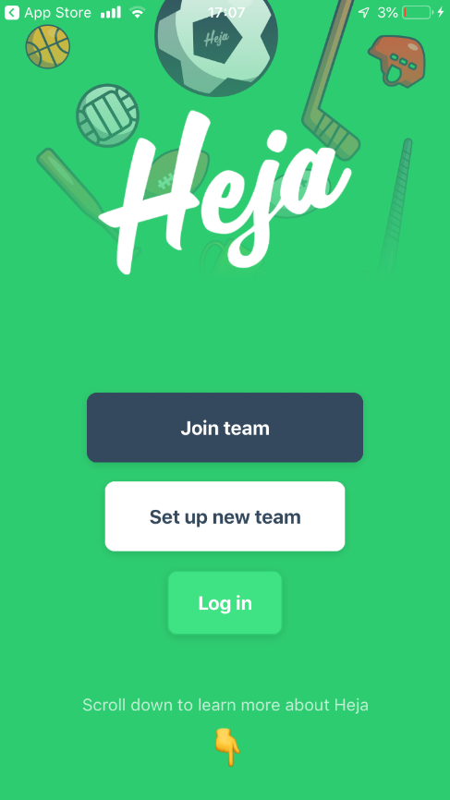

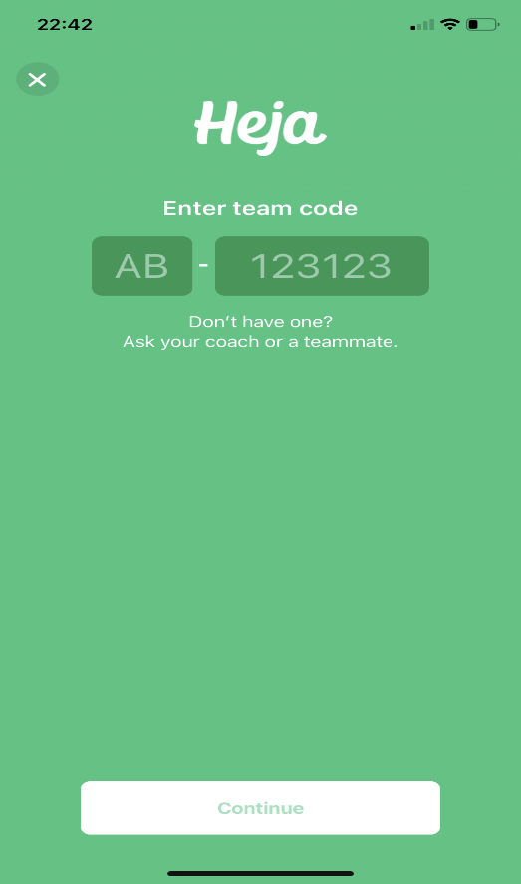

Go to: <https://heja.io> on your mobile device and download the Heja App through the applicable store (the App is free to download).

Click on Join Team.

Enter the Code for the 2023 Academy.

**EM-750996**

Enter your child’s name and select continue. A pop up will request you to review and confirm your child’s details.

6

5

4

Select Yes, I’m a parent

Choose an option to continue with. Your personal details can be added to or hidden after you register .

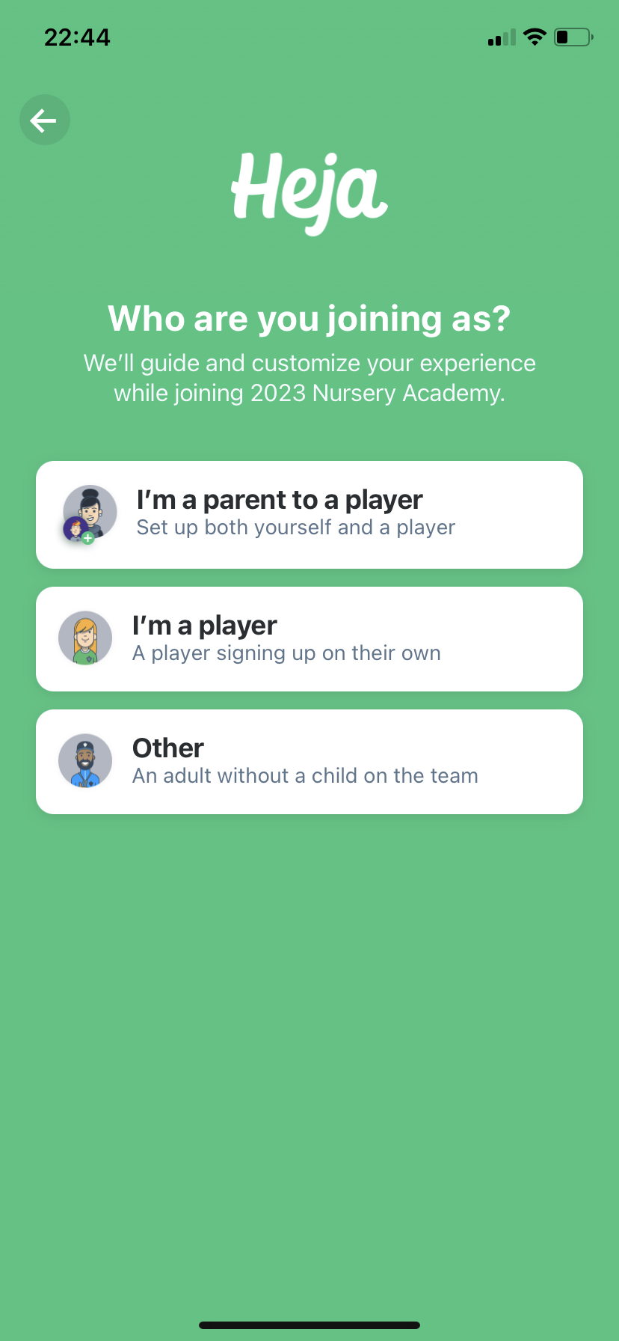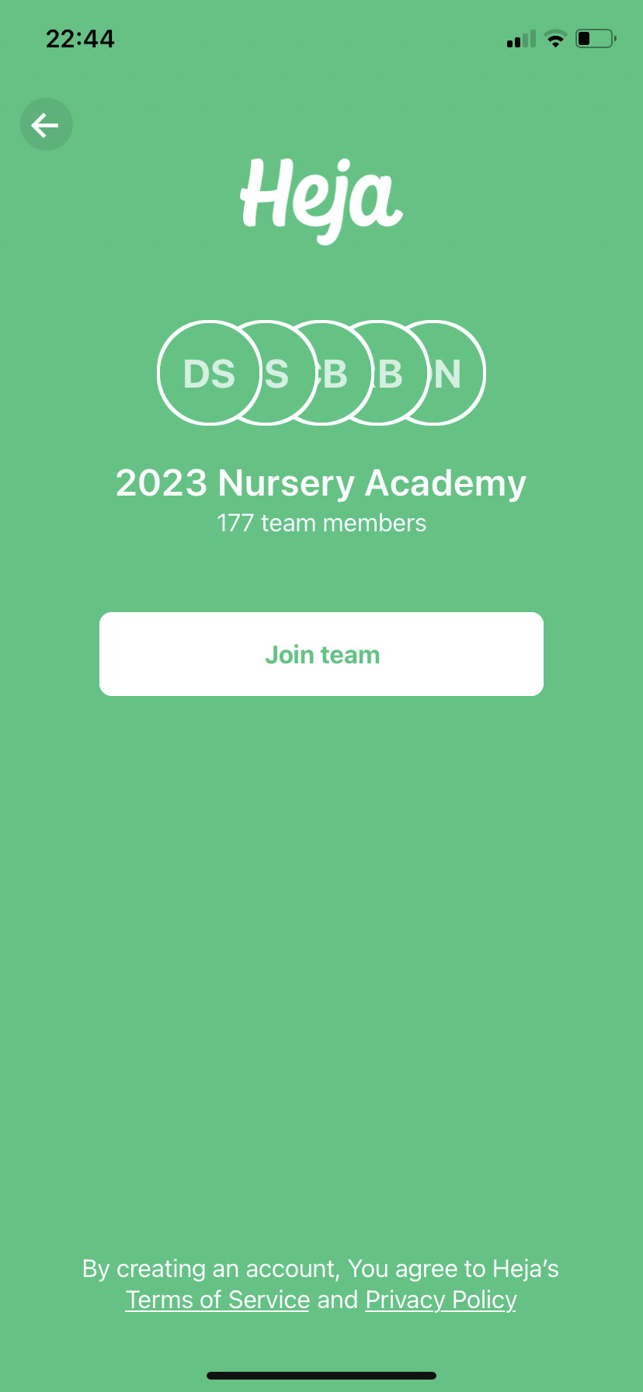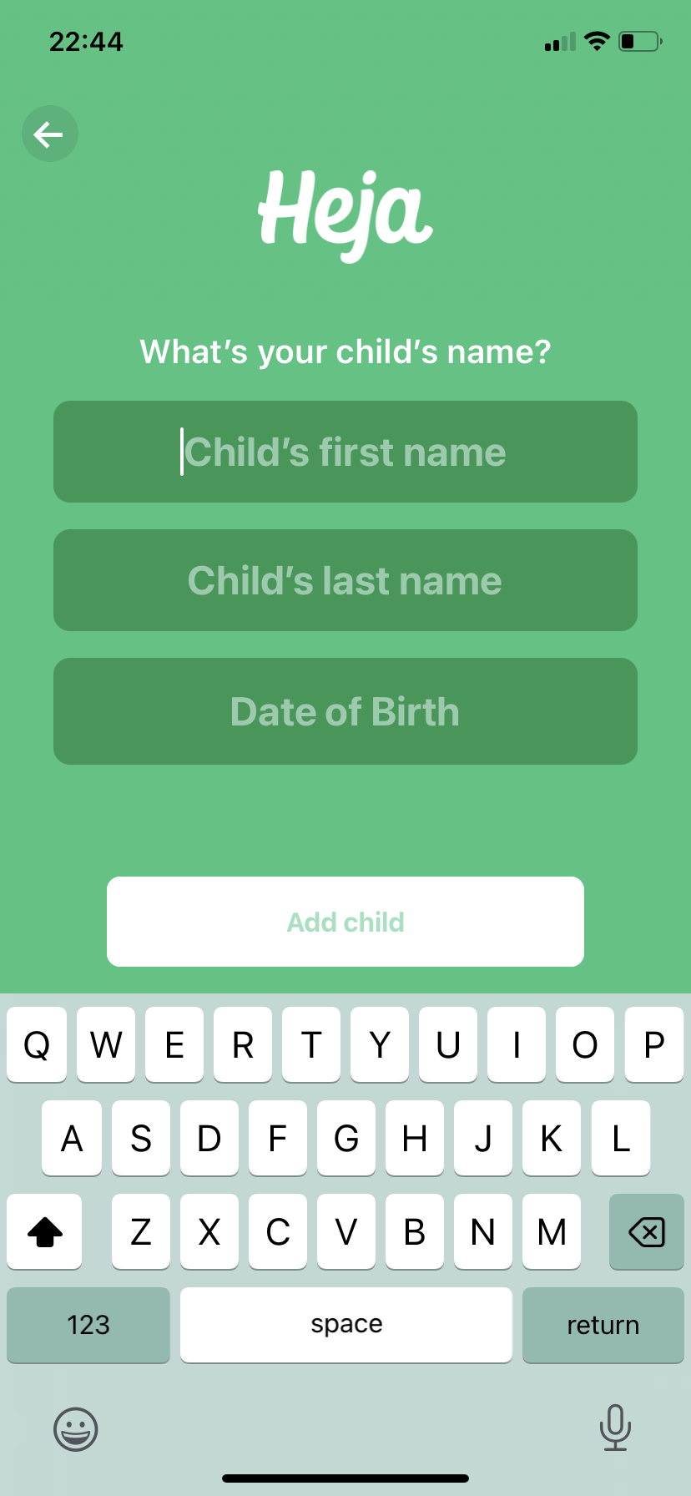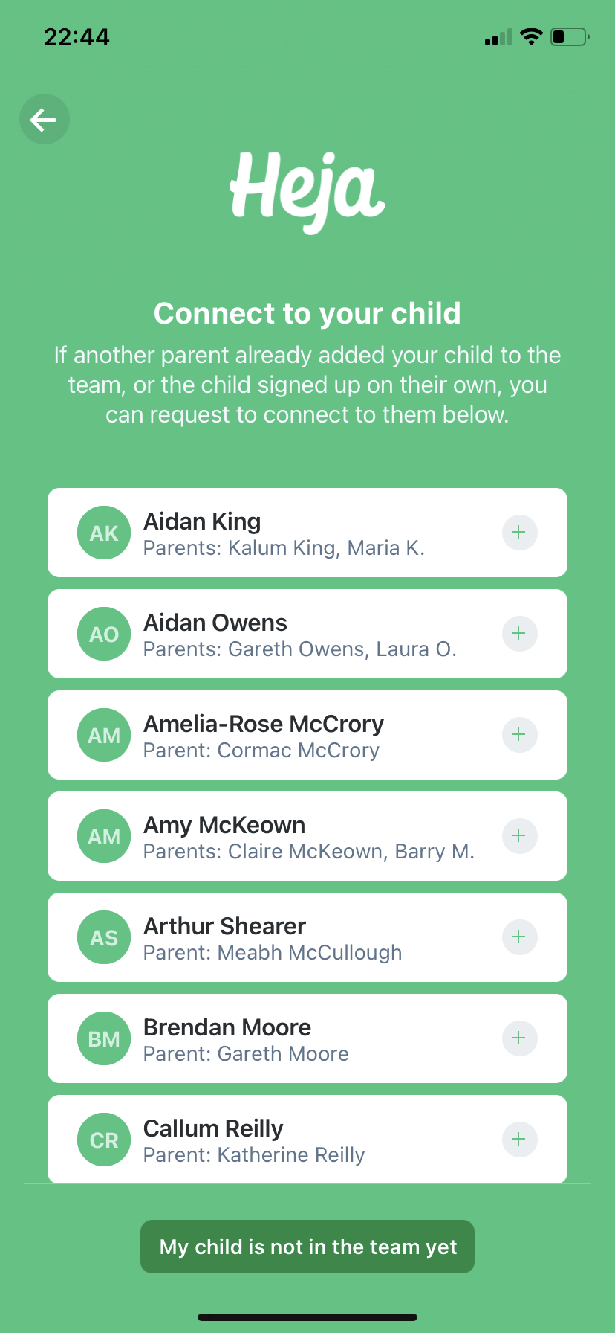

8

7

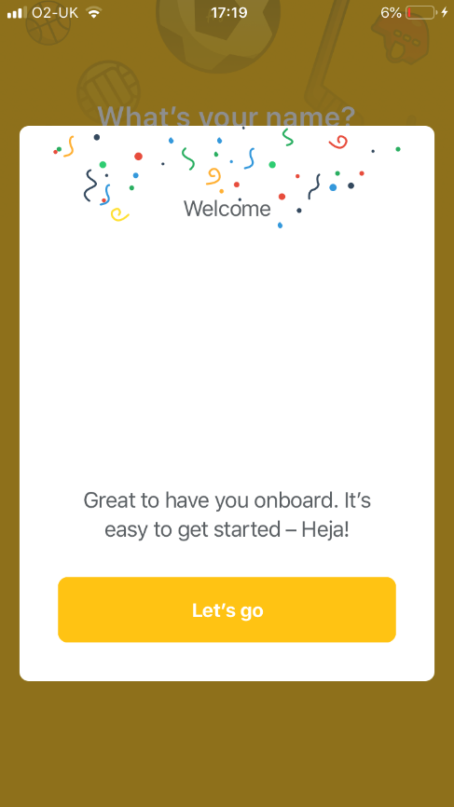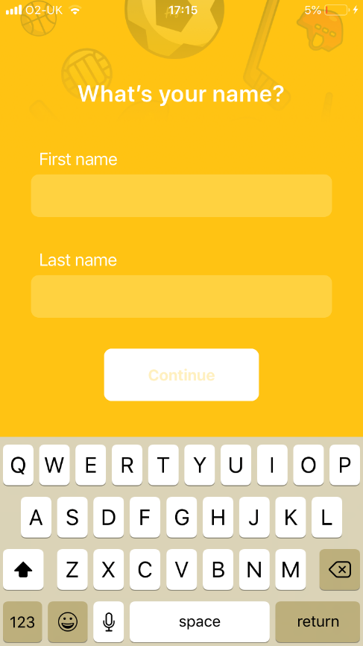

Enter your name and select continue. A pop up will request you to review and confirm your details. We would encourage you to add a photo of yourself as this helps everyone in the club to get to know one another. Leave blank if you would prefer not to.

Click Let’s go and you will be registered as a parent and your child will be registered as a player. If you have any queries, please contact the nursery co-ordinator.

Appendix B

Access NI Registration Guide

**A simple guide to completing Access NI checks**

Any adult assisting in any role with the mentoring or coaching of underage teams at Carryduff GAC should have completed an Access NI check in advance of taking up the role.

Existing coaches who have not completed an Access NI check within the last 2.5 years (i.e. before October 2020) should complete the process again in line with club policy.

**All coaches and mentors should be fully paid members of the club**

Information regarding Access NI checks can be accessed via Ulster GAA website

<http://ulster.gaa.ie/safeguarding/access-ni/>

1. Go to https://www.nidirect.gov.uk/services/apply-online-enhanced-check-through-registered-body to set up an account and complete the online element (Ulster GAA PIN is 540101).

2. At the end of the process make a note of your 10 digit Access NI reference number.

3. Complete the cover PIN notification and ID form (see Ulster GAA link above).

4. Scan the completed form and necessary ID documents (listed on page 4 of PIN notification and ID form).

5. Send all scanned documents by email to ([**childrensofficer.carryduff.down@gaa.ie**](mailto:childrensofficer.carryduff.down@gaa.ie)**)** who will verify your application and forward to Ulster GAA for processing.

6. You will receive your certificate within 4 weeks of application.

**Please Note**

- You must complete your application within one month of the date you applied online via NI Direct.

- Only scanned applications will be accepted this year.