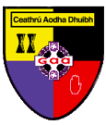

Annual General Meeting

30th November 2022

DEARBHÚ
DECLARATION

I (print name) _______________________ understand that the onus is on me to ensure that my nominations are delivered (before 8pm on Wednesday 16th November 2022) by email to (secretary.carryduff.down@gaa.ie), by post Secretary Carryduff GAC, Knockbracken Drive, Carryduff. BT8 8EX, failing which my nomination will not be counted.

Sínithe: _________________________________________

Ainm: _________________________________________

Uimhir ballraíochta: _________________________________________

(this can be found within your profile in Foireann)

